**MAJOR-1 PROJECT**

**SYNOPSIS REPORT**

For

Voyage Vista – Integrated Travel Booking Platform

Submitted By

|  |  |  |
| --- | --- | --- |
| **Specialization** | **SAP ID** | **Name** |
| Cyber Security & Forensics | 500091550 | Devisha Bhatnagar |
| Cyber Security & Forensics | 500091622 | Mohd Fahad Khan |



Department of Systemics

School Of Computer Science

UNIVERSITY OF PETROLEUM & ENERGY STUDIES,

DEHRADUN- 248007. Uttarakhand

Mr. Keshav Sinha Dr. Ajay Prasad

**Project Guide Cluster Head**



**School of Computer Science**

University of Petroleum & Energy Studies, Dehradun

**Synopsis Report**

**1. Project Title**

Voyage Vista – Integrated Travel Booking Plaform

**2. Abstract**

In today’s fast-paced world, the complexity of travel planning often results in fragmented booking experiences. This project addresses this challenge by developing an integrated travel booking platform designed to streamline the booking process for Flights, Hotels, and Tours. By consolidating multiple travel services into a single, user-friendly application, the platform enhances user convenience and efficiency. It leverages advanced scraping technology, such as the Bright Data API, to provide real-time availability and up-to-date information, ensuring users have access to the latest travel options. Payment transactions are securely managed through Stripe, adding an extra layer of safety and reliability. Built with full-stack development principles and Next.js integration, this solution delivers a comprehensive, cohesive, and seamless travel booking experience, effectively meeting the needs of modern travellers.

**3. Introduction**

In the evolving landscape of travel technology, the demand for integrated and efficient booking solutions has never been higher. This project introduces a cutting-edge travel planner app built with Next.js 14, designed to revolutionize how users book flights and hotels. The application combines advanced web scraping techniques and real-time data retrieval with a robust full-stack development approach, offering a seamless and intuitive experience for users.

The app leverages Puppeteer and Redis to facilitate dynamic scraping of flight and hotel information, ensuring that users have access to the latest and most accurate travel options. By integrating the Bright Data scraping browser, the platform ensures ethical data collection and compliance with legal standards while maintaining a high level of data accuracy and reliability.

Featuring a comprehensive admin dashboard, the app empowers administrators to manage user data, bookings, and scraping logs efficiently. User interactions are further enhanced by secure payment processing through Stripe, providing a smooth and secure transaction experience.

The development process includes the creation of a user-friendly interface for real-time data display, along with sophisticated backend functionalities such as job management for scraping tasks and API routes for data retrieval. The final deployment of the application on App Table showcases its performance and scalability, ensuring that users and administrators alike benefit from a well-rounded and highly functional travel booking solution.

This project not only addresses the need for a unified travel booking platform but also sets a new standard in travel technology by integrating real-time data access, secure payment processing, and a dynamic user interface, all within a single, cohesive application.

**4. Literature Review**

**4.1. History**

The evolution of the travel industry towards online platforms has created a complex landscape of choices for travellers. Online Travel Agencies (OTAs) offer a convenient means to search and book travel components, but fragmentation across different platforms remains a challenge. Voyage Vista seeks to streamline this process, providing an integrated solution that caters to the modern traveller’s needs. This project draws upon diverse research and technological advancements to deliver a seamless travel booking experience.

**4.2. Related Work**

Research into integrated travel booking platforms and the underlying technologies has been extensive:

1. **User-Centric Design and Personalization:** Chen et al. (2018) [1] emphasize the importance of user-centric design and personalization in travel planning systems. Voyage Vista will leverage user preferences and historical data to tailor recommendations and enhance the booking process.
2. **Unified Travel Platforms:** Industry leaders like Expedia Group [2] and Booking Holdings [3] have been consolidating various travel services into unified platforms. This trend underscores the demand for integrated solutions like Voyage Vista.
3. **Recommendation Systems:** Töscher & Jahrer (2009) [4] highlight the role of recommendation systems in travel planning. Voyage Vista will explore AI-driven recommendations to assist users in making informed choices.
4. **Big Data Analytics:** Zheng et al. (2018) [5] discuss the application of big data analytics in the tourism industry. Voyage Vista can leverage data insights to optimize search results and improve the user experience.
5. **Mobile Technology:** The rise of mobile devices has transformed travel planning. Xiang et al. (2017) [6] explore the impact of mobile technology on travel behavior. Voyage Vista will prioritize a mobile-first design to cater to this shift.
6. **Payment Systems:** Secure payment processing is critical for online travel bookings. The PCI Security Standards Council [7] provides guidelines for securing payment data. Voyage Vista will integrate with Stripe, adhering to best practices for payment security.

**4.3. Technology Landscape**

Voyage Vista's architecture will leverage a curated selection of technologies, each chosen for its specific strengths and alignment with project goals:

1. **Next.js:** Next.js hybrid rendering capabilities, enabling both Server-Side Rendering (SSR) and Static Site Generation (SSG), will ensure fast initial page loads and improved SEO, as highlighted in Vercel's documentation [8]. This aligns with the findings of Lian & Chen (2020) [14], who emphasize the importance of website performance in user experience and conversion rates.
2. **Prisma:** Prisma's type-safe ORM and intuitive data modeling approach streamline database interactions and improve developer productivity, as explained in the Prisma documentation [10]. This resonates with the emphasis on maintainability and code quality in modern software development practices [18].
3. **PostgreSQL:** PostgreSQL's robustness, extensibility, and support for complex data types make it a suitable choice for storing and managing the diverse data associated with travel bookings, as detailed in the PostgreSQL documentation [11]. Its reliability aligns with the need for data integrity in e-commerce platforms [16].
4. **Stripe:** Stripe's comprehensive payment processing capabilities and focus on security make it a trusted solution for handling online transactions, as outlined in the Stripe documentation [12]. Its PCI compliance ensures adherence to industry standards for protecting sensitive payment information [7].
5. **Additional Technologies:**
   * **Redis:** Redis can serve as a high-performance caching layer to accelerate data access and improve response times, particularly for frequently accessed data like search results or popular destinations, as explained in the Redis documentation [13].
   * **Web Scraping Tools:** Web scraping tools, such as Puppeteer or Cheerio, can automate the collection of data from various travel providers, ensuring that Voyage Vista offers up-to-date information and competitive pricing [14]. Ethical considerations and adherence to website terms of service are crucial in web scraping practices [16].

**5. Problem Statement**

1. The proliferation of Online Travel Agencies (OTAs) has undeniably simplified travel planning, yet the experience remains fragmented. Users often juggle multiple platforms for flights, accommodations, and other travel components, leading to inefficiencies and missed opportunities for optimization. Existing solutions frequently lack comprehensive integration, robust personalization, and real-time data aggregation.
2. Voyage Vista aims to bridge these gaps by developing a unified platform that streamlines the entire travel booking process. By leveraging advanced technologies like Kubernetes for scalable deployment, Prisma for efficient data management, and web scraping for real-time data aggregation, this project seeks to create a more seamless and personalized travel planning experience.

From a technical perspective, Voyage Vista presents a challenging and rewarding opportunity for skill development. It encompasses a wide range of technologies relevant to modern software development, including:

* **Full-stack development with Next.js:** Gaining proficiency in a widely-used React framework that enables efficient rendering and server-side capabilities, skills highly sought after in the industry.
* **Database management with Prisma and PostgreSQL:** Mastering data modeling, efficient querying, and ensuring data integrity, essential skills for any software engineer.
* **Payment integration with Stripe:** Ensuring secure and seamless payment processing, vital for e-commerce platforms and applications.
* **Web scraping and data aggregation:** Acquiring and processing real-time data from various sources, valuable for building data-driven applications and insights.

By tackling these technical challenges, Voyage Vista not only aims to create a superior travel booking platform but also to equip me with the skills and knowledge necessary to excel in a rapidly evolving technological landscape. It is my aspiration that this project will serve as a testament to my ability to apply theoretical knowledge to real-world problem-solving and position me for a successful career in the software industry.

|  |  |  |  |  |
| --- | --- | --- | --- | --- |
| Technology | Alternative | Strengths | Weaknesses | Relevance to Voyage Vista |
| Front-End Framework | | | | |
| Next.js (React-based) | Create React App, Gatsby, Vue.js, Angular | - Hybrid rendering (SSR/SSG) for performance & SEO - Built-in routing & API routes - large community & ecosystem | - Opinionated structure - Learning curve for React beginners | - Enables efficient rendering and seamless user interactions - Facilitates fast page loads and improves SEO, crucial for user experience and discoverability |
| Database | | | | |
| PostgreSQL | MySQL, MongoDB, Firebase | - Robust & scalable relational database - Support for complex data types & transactions - Strong community & extensive documentation | - Can be more complex to set up & manage than some NoSQL options | - Ideal for storing and managing structured travel data (flights, hotels, bookings) - Ensures data integrity and supports complex queries for search and filtering |
| ORM | | | | |
| Prisma | TypeORM, Sequelize, Mongoose | - Type-safe & intuitive data modelling - Automatic migrations & schema management - Active development & growing community | - Relatively new compared to some ORMs - May require additional learning for developers unfamiliar with Prisma's approach | - Simplifies database interactions and promotes clean code - Facilitates efficient data management and reduces development time |
| Payment Processing | | | | |
| Stripe | PayPal, Braintree, Square | - Wide range of payment methods supported - Robust security & fraud prevention features - Developer-friendly API & documentation | - Transaction fees can be higher than some alternatives - May require additional setup for certain features or regions | - Enables secure and convenient payment processing - Ensures compliance with industry standards for handling sensitive payment data |
| Web Scraping | | | | |
| Puppeteer (Node.js library) | Cheerio, Playwright, Selenium | - Headless browser automation for dynamic websites - Full control over browser interactions - Can handle complex scraping scenarios | - Can be resource-intensive - Requires knowledge of JavaScript & browser automation | - Enables real-time data aggregation from various travel providers - Ensures up-to-date information and competitive pricing on the platform |

**6. Objectives**

**6.1. Main Objectives**

**Unified Travel Booking Experience:**

* Develop a single platform that seamlessly integrates the booking of flights, accommodations, and potentially other travel components like car rentals and activities.
* Eliminate the need for users to navigate multiple platforms, providing a more convenient and streamlined booking process.

**Real-Time Data Aggregation and Presentation:**

* Utilize web scraping techniques to gather and present the latest travel information, including prices, availability, and deals.
* Ensure users have access to the most up-to-date and competitive options when planning their trips.
  1. **Other Objectives**

1. **Scalable and Resilient Architecture:**

Employ cloud-native technologies and best practices to build a robust and scalable platform capable of handling varying traffic loads and ensuring high availability.

1. **Efficient Data Management:**

Implement a well-structured database and efficient data management practices to enable fast and reliable access to travel data and user information.

1. **Secure Payment Processing:**

Integrate a trusted payment gateway to provide a secure and seamless payment experience for users, adhering to industry standards for data protection.

1. **User-Friendly Interface:**

Design an intuitive and visually appealing interface that simplifies the travel planning and booking process, making it accessible to all users.

1. **Skill Development and Learning:**

Serve as a platform for acquiring and refining technical skills in full-stack development, database management, payment integration, and web scraping.

Enhance career prospects in the software industry by gaining hands-on experience with relevant technologies.

1. **Problem-Solving and Innovation:**

Demonstrate the ability to analyze complex challenges in the travel booking domain and develop effective solutions through innovative application of technology.

By achieving these objectives, Voyage Vista aims to redefine the online travel booking experience, offering a unified, personalized, and efficient platform that empowers travellers to plan and book their trips with ease.

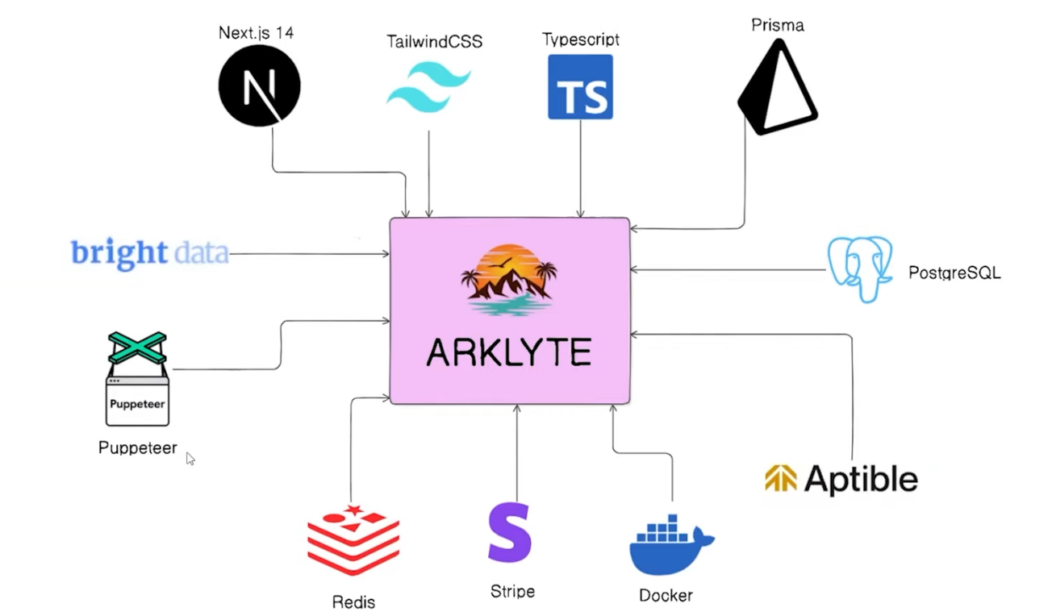**7. Methodology**

VOYAGE VISTA

**7.1. Implementation Process**

**1. Setting Up the Development Environment**

* Ensure the latest stable versions of Node.js and npm are installed.
* Utilize the create-next-app command to initialize a new Next.js project.
* Install necessary dependencies for both front-end and back-end development.

**2. Front-End Development**

* Design and implement reusable React components for the user interface.
* Prioritize a responsive and mobile-first design.
* Utilize Next.js's built-in routing for seamless navigation.
* Fetch and display travel data dynamically using API calls and React's state management.
* Handle user interactions through event handlers.
* Integrate with external APIs for maps, payment processing, and other services.

**3. Back-End Development**

* Develop the back-end using Node.js and Express.js or a similar framework.
* Define API endpoints using Next.js's API routes.
* Gather real-time travel data using web scraping techniques with Puppeteer.
* Store and retrieve data using Prisma and PostgreSQL.
* Implement business logic for searching, filtering, sorting, and processing travel data.
* Integrate with Stripe for secure payment processing.

**4. Database Management**

* Design the PostgreSQL database schema with appropriate tables and relationships.
* Create Prisma models to represent database tables and their properties.
* Use Prisma Client to perform CRUD operations and fetch data for the back-end.

**5. Web Scraping**

* Select target travel websites for data aggregation.
* Analyze website structure and identify data elements.
* Develop Puppeteer scripts to automate browser interactions and data extraction.
* Handle dynamic content and implement error handling/retries for robustness.

**6. Integration & Testing**

* Ensure seamless communication between front-end and back-end using API calls.
* Conduct comprehensive testing, including unit, integration, and end-to-end tests.
* Gather user feedback through user testing to validate the user experience.

**7.2. Flowchart**

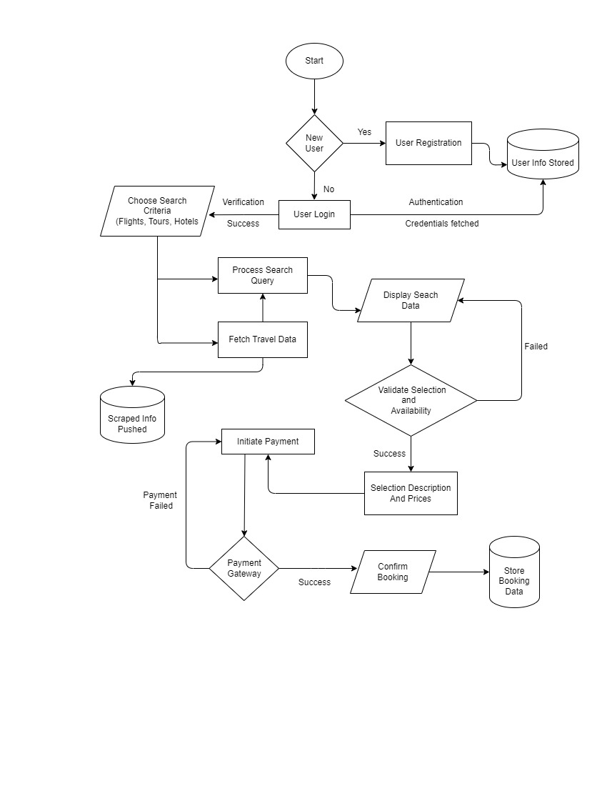

1. **PERT Chart**

|  |  |
| --- | --- |
| STUDY PERIOD | |
| 001 | 20 DAYS |
| 15 AUG 2024 | 05 SEP 2024 |

|  |  |
| --- | --- |
| REQUIREMENT GATHERING | |
| 002 | 4 DAYS |
| 06 SEP 2024 | 10 SEP 2024 |

|  |  |
| --- | --- |
| DESIGN | |
| 004 | 3 DAYS |
| 19 SEP 2024 | 22 SEP 2024 |

|  |  |
| --- | --- |
| DOCUMENTAION | |
| 003 | 8 DAYS |
| 10 SEP 2024 | 18 SEP 2024 |



|  |  |
| --- | --- |
| TESTING | |
| 006 | 4 DAYS |
| 23 OCT 2024 | 27 OCT 2024 |

|  |  |
| --- | --- |
| CODING and IMPLEMENTATION | |
| 005 | 30 DAYS |
| 22 SEP 2024 | Est. 22 OCT 2024 |

|  |  |
| --- | --- |
| DEBUGGING | |
| 007 | 5 DAYS |
| 27 OCT 2024 | Est. 01 NOV 2023 |

|  |  |
| --- | --- |
| REPORT PUBLISH | |
| 008 | 20 DAYS |
| 01 NOV 2023 | Est. 20 NOV 2023 |

**9. References**

1. Chen, L., Wang, S., & Liu, J. (2018). A framework for an integrated travel planning and booking system based on big data analytics. Tourism Management, 69, 456-470.

2. Expedia Group. (2023). Annual Report.

3. Booking Holdings. (2023). Annual Report.

4. Töscher, A., & Jahrer, M. (2009). The Big Five of Tourism Marketing. Journal of Travel Research, 48(1), 14-24.

5. Zheng, Z., Qin, R., Chen, Q., & Chau, M. (2018). Big data analytics in tourism research: A review. Tourism Management Perspectives, 28, 120-128.

6. Xiang, Z., Tussyadiah, I., & O'Leary, J. T. (2017). Understanding the role of mobile technology in travel information search. Journal of Travel Research, 56(3), 365-378.

8. Next.js Documentation. (2023). Retrieved from https://nextjs.org/docs

10. Prisma Documentation. (2023). Retrieved from https://www.prisma.io/docs/

11. PostgreSQL Documentation. (2023). Retrieved from https://www.postgresql.org/docs/

12. Stripe Documentation. (2023). Retrieved from https://stripe.com/docs

13. Redis Documentation. (2023). Retrieved from https://redis.io/docs/

14. Lian, J.-W., & Chen, L.-Y. (2020). Impact of website quality on customer satisfaction and purchase intention: The moderating role of perceived value. International Journal of Information Management, 50, 395-404.

15. Martin, R. C. (2008). Clean code: A handbook of agile software craftsmanship. Pearson Education.

16. Tari, Z. (2019). E-commerce security and payment systems. In Security in Computing and Communications (pp. 3-12). Springer.

17. Zafar, M. B., Liu, X., & Ma, W. (2019). Ethical considerations in web scraping and implications for online travel reviews. Journal of Vacation Marketing, 25(3), 274-287.